University ID and verification system using Python and regular expressions
Programming II (CSC202)

Abstract

The project we are embarking on intends to develop a Python program which incorporates pattern expressions for the analysis of a group of inputs that consist of university ID numbers. The program receives several user inputs and then checks each one against a pattern that signifies a valid university ID. Such a pattern usually has the form of eight digits and starts with either 44, 45, or 46. After the verification, the program will take out the matching parts for each input and will then present the results in a clear way, marking if the input is valid, and revealing the extracted ID. To implement the code, it is divided into two parts: a module file that contains functions for matching and extraction using Python’s built-in re library, and a main file that interacts with the user and displays the results.

Introduction
The digital transformation of educational institutions played an important role in the increasing demand for sophisticated technology for data manipulation and verification. The primary goal of this project is to develop an application that is both powerful and user-friendly, through which a user can verify a university ID number's authenticity. The system, which is written in Python, utilizes regular expressions to detect numbers that match a specific pattern—those starting with 44, 45, or 46, and having a total of 7 digits. Users can enter full sentences containing the ID numbers, and the software will carry out the process of filtering out only the valid numbers while the incorrect, duplicate, or invalid numbers will be left out. Hence, the project is improving the quality of data not only but also producing a more vivid and accurate representation in the results that will be experienced by the users during their interaction with the system.

Problem definition and Suggested solution

In the course of creating the university ID validation program, a number of practical concerns were recognized that have a direct impact on the accuracy as well as the user experience. First and foremost, a large proportion of the users tend to enter incorrect or partially filled ID numbers which results in invalid outputs. Another concern is that there may be several numbers in one phrase and the system cannot tell which one to process. What's more, there is no consistency in the input provided by the users—they could use any of the three forms: "my ID is," "ID is," or even nothing—so it becomes even more difficult to do pattern matching. Also, duplicates may occur and that will lead to extra and probably even harder and more confusing results in the analysis.

The difficulties experienced resulted in the birth of a programming solution set which came out to be very effective. To begin with, a very accurate regular expression was used to not only get the input ID but also its exact structure which is 44, 45, or 46 followed by seven digits thus making sure the input is valid. After that, the program was designed in a way that it would get the first matched number regardless of how many numbers there are in the sentence. Furthermore, each input is getting normalized by changing the case to lowercase and ignoring the formatting which, in turn, makes it easier to find the patterns. Finally, a set() data structure is employed to retain the uniqueness of the inputs, thus ensuring that each phrase is processed only once.

Gantt chart
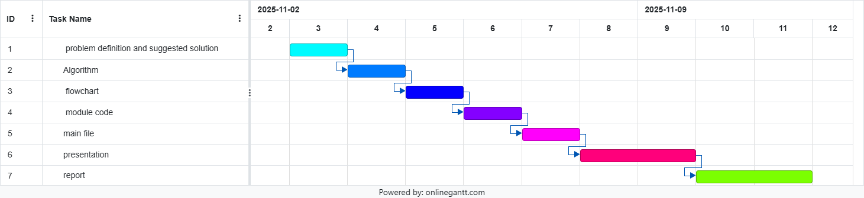
We made a clear and organized timeline for the stages of our University ID Verification project using this Gantt chart. We started by figuring out what the problem was and coming up with a solution. This was the basis for the whole project. Next, we made a flowchart to show how the program works, and then we made the algorithm to explain how it works. After the design was done, we coded each module and then put them all together into the main file that runs the system. After we finished the programming phase, we spent time getting ready for the presentation to explain the project clearly. Finally, we wrote the final report to record all the steps we took. This timeline helped us plan our work, set priorities, and make sure that each step made sense in relation to the one before it.

1.Algorithem
- Start by making an empty set called ID to hold unique user inputs.
- Set a counter num = 1 to mark each line of input.
- Keep doing the steps below until the user types "done":
- Ask the user, "What is {num} ID?"
- Change the input to all lowercase letters and save it in answer.
- If the answer is "done," leave the loop.
- Add the answer to the ID set.
- Add 1 to num.
- For every item m in the ID set:
- Use the function match(m) to see if the input has a valid pattern for a university ID.
- Use the matching_parts(m) function to get the matching ID number(s).
- Show:
- The first thing you put in.
- If it fits the pattern, say "Yes" or "No."
- The university ID number(s) that were taken out or "nothing."
- The end
2.Flowchart
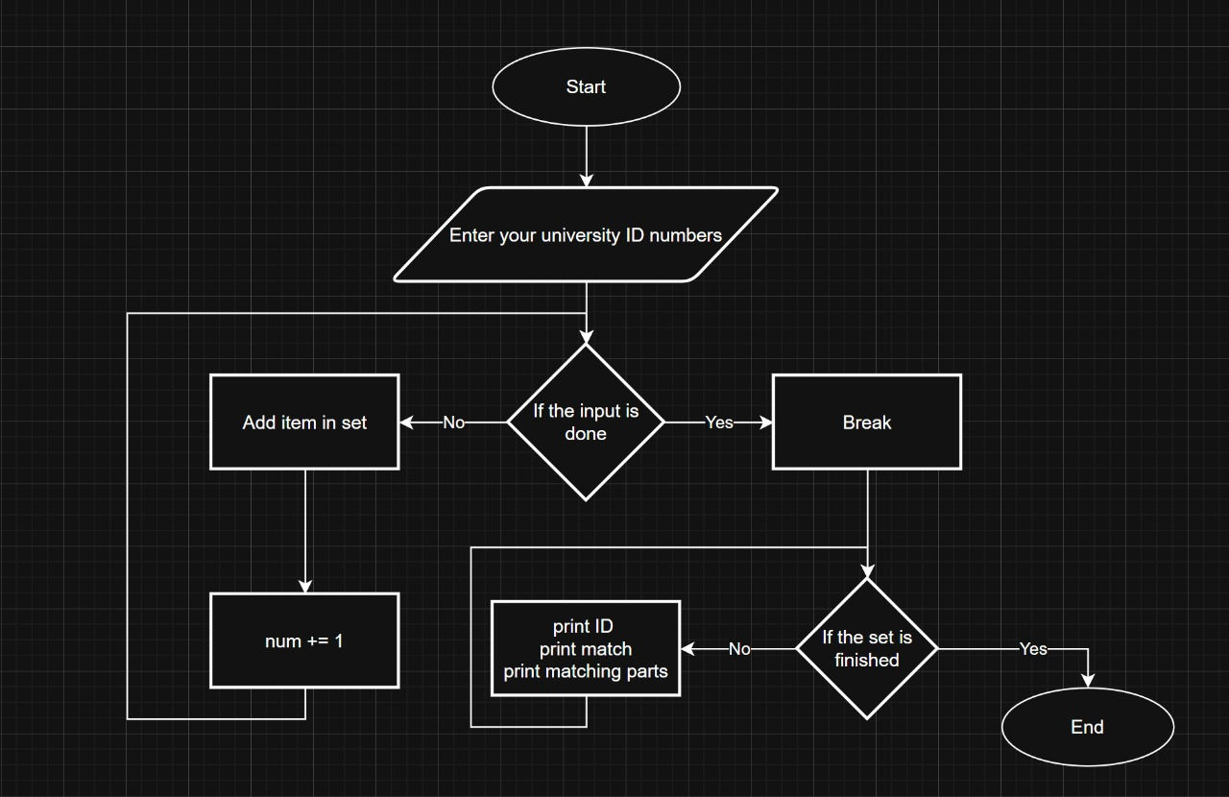
This flowchart depicts the order of execution in the Python program for validating university IDs. The user is instructed to enter university IDs, and then the program goes into a loop asking for more. Within the loop, it checks if the user is done by noting the input of "done." If not done, the input is stored in a data set, the num counter is incremented, and the loop begins again. After the input phase ends, the next phase is to process the IDs within the data set. The program checks and validates each ID for accuracy and will report back to the user on each entered ID. The flowchart structure aids in understanding visibly, how the program transitions from input, to validate, and back to output in an executable manner.

3.Code
3.1.module file
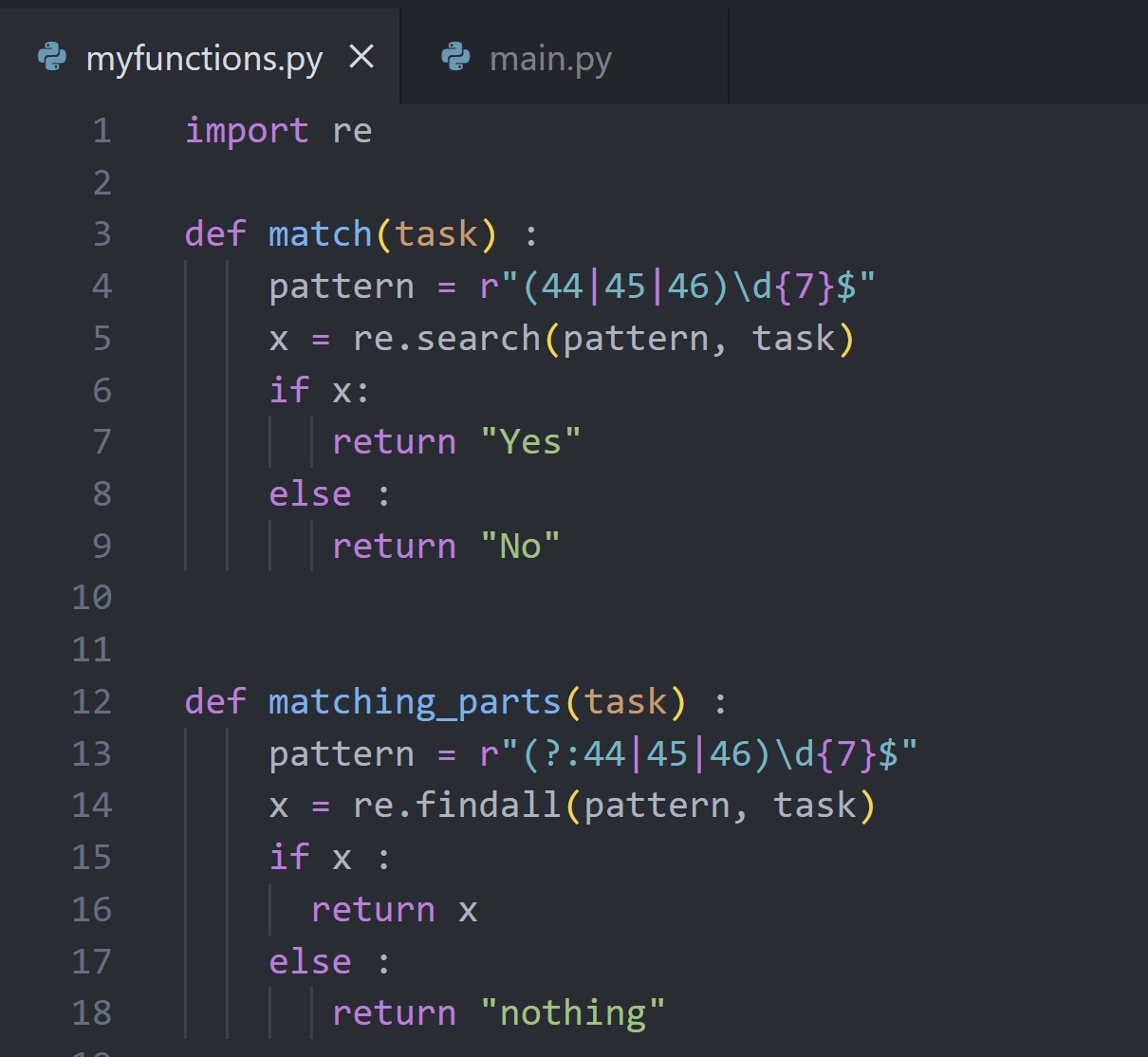
This document has two functions that use a regular expression to find a university ID number in text. The first function, match(task), checks the input for an ID number which starts with either 44, 45, or 46 followed by seven digits. It will return a "Yes" or "No" depending if there are any matches. The second function, matching_parts(task), parses the text and returns all the matching parts of the text in that same format, or "nothing". This separation of validation and extraction keeps the code apparent and organized.

3.2.main file
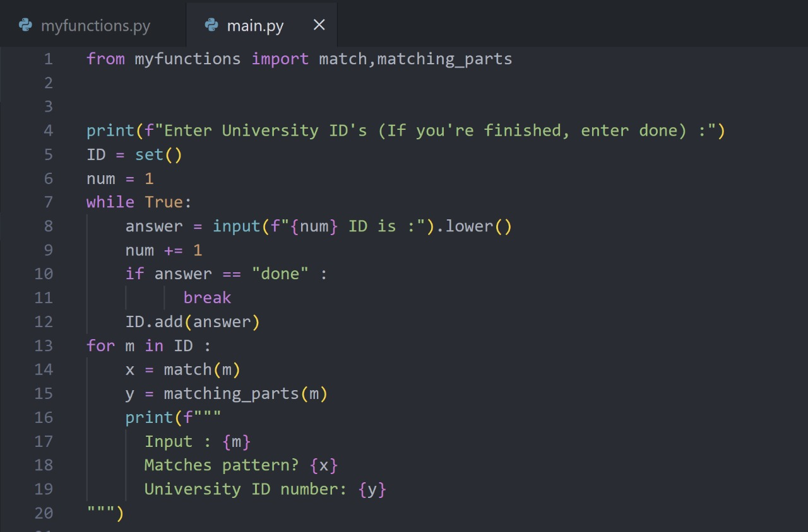
The main program that a user will interact with is in this file. This program begins by prompting the user to enter some phrases that may contain university ID numbers, and continues to prompt for phrases until the user enters "done". The phrases are saved into a set to avoid duplicates, and then each phrase is passed to the match and matching_parts functions imported from the other file. The output for each phrase indicates whether that phrase has a valid ID number and what that ID number is (if there is one). Overall, the code is more accurate and clear due to the new pattern and usage of the code.

3.3.Output
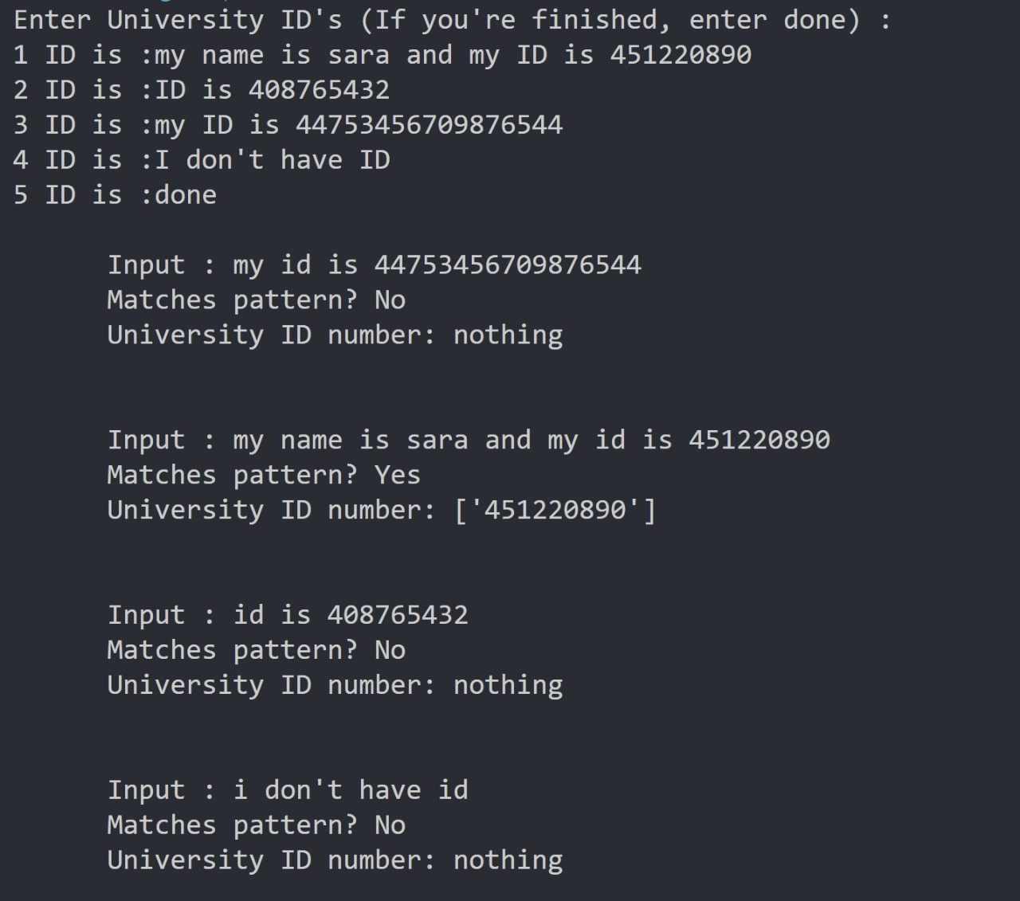
The output shows the response to all of the user's input statements, as well as the validated ID number. The program uses a regular expression to check that the university ID number is a 10-digit number that starts with 44, 45, or 46. The only phrase that worked in this input was "my name is sara and my ID is 451220890," which gave the output "Yes" along with that number as the university ID number. The other phrases either had invalid university ID numbers or no number at all, which is why the output was "No" and "nothing." This shows that the program is correctly checking the ID number against the rules that were set up before.

3.4.Link
module file
main file

Conclusion
summary, the University ID Verification System demonstrates the successful use of Python and regular expressions to validate user input data and extract specific patterns. The project was able to achieve the objective of allowing users to enter text strings that may contain university ID numbers and validate the text strings. Both the use of sets and regular expressions greatly enhanced accuracy and performance in that records with duplicates were removed and validated records were valid university ID numbers. The project exhibited the importance of both validating data as well as recognizing patterns in applications especially with educational institutions that use systematic and digital systems of verification.

Thank you

